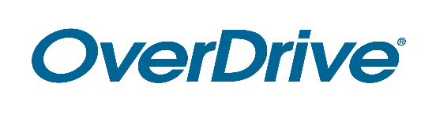
Library Logo

FOR IMMEDIATE RELEASE

Popular Ebooks and Digital Audiobooks [and Digital Magazines] Available Free 24/7 From Library Name
Readers can use the award-winning Libby app to enjoy digital books on any device

CITY, State or Region – Month Day, Year – As people increasingly read and listen to books on their smartphone or tablet, they’re discovering one of the best resources is their local public library. City/County residents can access a wide selection of popular digital ebooks and audiobooks (if applicable: and digital magazines) free from Library name. With a library card, members of the community can borrow from the digital collection by downloading Libby, the award-winning reading app from OverDrive, or visiting OverDrive library website URL.

[Quote from Library staff member (excitement about the service, first-hand experience using the service, etc.)]

Named one of Popular Mechanics’ 20 Best Apps of the Decade, Libby seamlessly connects first-time users and experienced readers with Library name’s digital collection. This locally selected collection offers ebooks and audiobooks (if applicable: and digital magazines) including bestsellers and new releases. Readers of all ages can select from virtually every subject ranging from mystery, romance, children’s, business and more.

Readers may browse Library name’s digital collection, instantly borrow titles and start reading or listening for free with a valid library card. This service is compatible with all major computers and devices, iPhone®, iPad®, Android™ phones and tablets and Chromebook™. Through Libby, readers can also “send to Kindle®” [U.S. only]. All titles will automatically expire at the end of the lending period and there are no late fees. Readers can also download titles onto Libby for offline use.

To get started enjoying ebooks, audiobooks and more, download Libby or visit OverDrive library website URL.

About Library name
Add boilerplate description

About OverDrive
OverDrive strives to create “a world enlightened by reading.” Serving a growing network of 73,000 libraries and schools in 88 countries, OverDrive delivers the industry’s largest digital catalog of ebooks, audiobooks, magazines and other content through award-winning apps. The Libby reading app for libraries is one of Popular Mechanics’ 20 Best Apps of the Decade, while the student reading app Sora is one of TIME’s Best Inventions of 2019. Founded in 1986, OverDrive is based in Cleveland, Ohio USA and was named a Certified B Corp in 2017. www.overdrive.com

Contact:
Library contact name
Library name
Phone number
Email address

###

