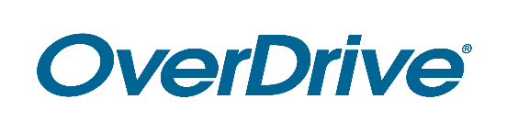
Library Logo

FOR IMMEDIATE RELEASE

Library Name Creates Dedicated Digital Space for [eReading Room/Catalog Guide Name]
Ebooks and audiobooks grouped together allows for convenient, easy browsing on Libby reading app and website

CITY, State or Region – Month Day, Year – Libraries have long embraced the digital age and continue to add conveniences to serve the members of their community. Library name has digitized the sections of a physical library branch by creating a specialized dedicated space of [insert eReading room/catalog guide name] ebooks and audiobooks. With a library card, City Name residents can browse digital books sectioned off from the rest of the catalog with all searches filtered and dedicated to [eReading room/catalog guide name or description]. Readers can find this on Libby, the award-winning one-tap reading app from OverDrive, or [insert Library’s OverDrive website URL].

[Quote from Library staff member (excitement about the service, benefits seen by staff/patrons, etc.)]

Library name’s digital collection offers thousands of ebooks and audiobooks [if applicable: and digital magazines] in a variety of genres for all ages. Readers may browse the full digital catalog, instantly borrow titles and start reading or listening for free with a valid library card. This service is compatible with all major computers and devices, iPhone®, iPad®, Android™ phones and tablets and Chromebook™. Through Libby, readers can also “send to Kindle®” [U.S. only]. All titles will automatically expire at the end of the lending period and there are no late fees. Readers can also download titles onto Libby for offline use.

To explore the library’s ebooks, audiobooks and more, download Libby or visit [Library’s OverDrive website URL].

About Library name
Add boilerplate description

About OverDrive
OverDrive strives to create “a world enlightened by reading.” Serving a growing network of 76,000 libraries and schools in 94 countries, OverDrive delivers the industry’s largest digital catalog of ebooks, audiobooks, magazines and other content through award-winning apps. The Libby reading app for libraries is one of Popular Mechanics’ 20 Best Apps of the Decade, the Sora student reading app is one of TIME’s Best Inventions of 2019, and Kanopy is the leading streaming video service for libraries and colleges. Acquired in 2021, TeachingBooks.net offers one of the largest catalogs of supplemental materials that enhance literacy outcomes. Founded in 1986, OverDrive is based in Cleveland, Ohio USA and was named a Certified B Corp in 2017. www.overdrive.com

Contact:
Library contact name
Library name
Phone number
Email address

###

