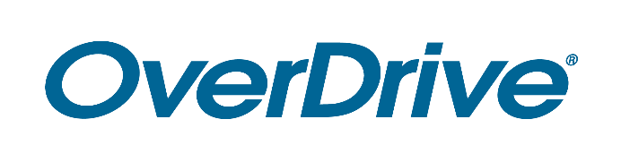
Library logo

FOR IMMEDIATE RELEASE

Over 3,000 Popular Magazines Now Available for Download through Library name
Readers can enjoy [insert 2-3 popular titles] and more through the Libby reading app

CITY, State – Month Day, Year – Library name is pleased to announce that over 3,000 popular magazines are now available to download and read on any device 24/7. Users with a library card can read digital magazines alongside ebooks and audiobooks on Libby, the award-winning reading app from OverDrive, or by visiting [Library’s OverDrive website URL]. Top titles include [list 2-3 top titles] and many other popular magazines, all supplied by ZINIO [Optional: (previously available through the RBdigital app)].

[Quote from Library staff member (excitement about the service, benefits to patrons, etc.)]

A sampling of digital magazines available include: List 5-10.

Digital magazines have no wait lists or holds, do not count towards checkout limits and provide readers the option to renew their selections. Library name patrons can also download magazines to Libby for offline use. Readers can browse lists of magazines within the app and search by format to find available titles.

Named one of Popular Mechanics’ 20 Best Apps of the Decade, Libby seamlessly connects first-time users and experienced readers with Library name’s digital collection. This locally selected collection offers ebooks and audiobooks [if applicable: and digital magazines] including bestsellers and new releases. Readers of all ages can select from virtually every subject ranging from mystery, romance, children’s, business and more.

Readers may start reading or listening for free with a valid Library name library card. This service is compatible with all major computers and devices, iPhone®, iPad®, Android™ phones and tablets and Chromebook™. Through Libby, readers can also “send to Kindle®” [U.S. only]. All titles will automatically expire at the end of the lending period and there are no late fees. Readers can also download titles onto Libby for offline use.

To get started enjoying magazines, ebooks and audiobooks, download Libby or visit [Library’s OverDrive website URL].

About Library name
Add boilerplate description

About OverDrive
OverDrive strives to create “a world enlightened by reading.” Serving a growing network of 76,000 libraries and schools in 94 countries, OverDrive delivers the industry’s largest digital catalog of ebooks, audiobooks, magazines and other content through award-winning apps. The Libby reading app for libraries is one of Popular Mechanics’ 20 Best Apps of the Decade, the Sora student reading app is one of TIME’s Best Inventions of 2019, and Kanopy is the leading streaming video service for libraries and colleges. Acquired in 2021, TeachingBooks.net offers one of the largest catalogs of supplemental materials that enhance literacy outcomes. Founded in 1986, OverDrive is based in Cleveland, Ohio USA and was named a Certified B Corp in 2017. www.overdrive.com
Media Contact:
Library contact name
Library name
Phone number
Email address

###

