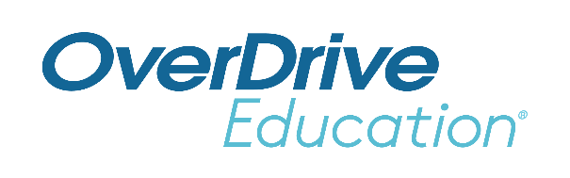
School Logo
FOR IMMEDIATE RELEASE

School Name Students Read Over One Million Digital Books
Educators embrace digital to encourage students to read school’s ebooks, audiobooks (and magazines) anytime, anywhere

CITY, State or Region – Month Day, Year – As schools embrace the digital shift and rely more on digital books to support learning outcomes, educators are adapting their curriculum to include more ebooks and audiobooks in the classroom. Today, School name announced that their students have read a total of X million digital books since the school first offered ebooks and audiobooks in year. This milestone illustrates educators' and administrators' success with embracing new strategies to eliminate barriers to reading and overcome unequal access to books. These efforts have resulted in more opportunities for student reading of educational and popular digital books year-round.
Through School name’s Sora student reading app, students have convenient and safe access to hundreds OR thousands of age-appropriate ebooks and digital audiobooks (and magazines) from the school’s (If applicable: as well as the public library’s) collection(s). These books can be read or listened to 24/7 on any device both inside and outside the classroom. Data from thousands of schools using Sora shows students of all ages read more when they have more access to reading choice. Industry research indicates ebooks and audiobooks improve comprehension and critical listening.
(School staff member quote about milestone/Sora– excitement, benefits, etc.)
Inspired by educator and student feedback, Sora provides seamless access to both assigned and pleasure reading within the app, incentivizing learning through fun avatars and achievements. Sora also supports teachers by offering classroom-specific tools like personal assignments, reading analytics and exportable notes that individualize learning.
Sora, named one of TIME’s Best Inventions of 2019, was built by OverDrive Education, a division of OverDrive serving over 53,000 K-12 schools worldwide. OverDrive is the leading digital reading platform for a growing network of 76,000 libraries – including local Library name – and schools in 94 countries.
The Sora app is available for School name students, faculty and staff to download through the Apple App Store and Google Play Store, and on Chromebooks that support the Google Play Store. It is also available for use in web browsers at https://soraapp.com.
To learn more, visit http://discoversora.com.

About School Name
Add boilerplate description

About OverDrive Education and the Sora student reading app
OverDrive Education, a division of OverDrive, offers the industry’s largest catalog of ebooks, audiobooks, and digital magazines for over 53,000 K-12 schools and millions of students worldwide. The company's student reading app, Sora, provides every student with access to the right books. Supporting the need to read required curriculum titles, class sets and pleasure reading digital books, Sora’s powerful learning tools and insights help meet the needs of students and educators. Sora was named one of TIME’s Best Inventions of 2019. Acquired in 2021, TeachingBooks.net offers one of the largest catalogs of supplemental materials that enhance literacy outcomes. Founded in 1986, OverDrive – the leading digital reading platform for libraries – and OverDrive Education are based in Cleveland, Ohio USA. www.overdrive.com/schools

Contact:
School contact name
School name
Phone number
Email address
###

