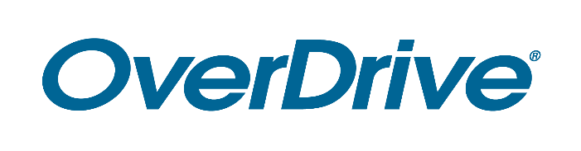
*Recommendation: email to press on Nov 2

FOR IMMEDIATE RELEASE

Library Name Readers Explore Secret Worlds During World’s Largest
Digital Book Club
Riveting fantasy “Reverie” ebook and audiobook now available for reading and discussion with global audience

CITY, STATE – Month Date, 2020 – Library name is connecting their patrons with millions of readers and a compelling young adult ebook during the next Big Library Read, the world’s largest digital book club. From November 2-16, readers’ secret dreams can become a reality when they borrow and read Ryan La Sala’s debut novel Reverie from their public library. Library name library card holders can borrow the ebook or audiobook without waiting by visiting [insert link to your digital collection; http://xxx.lib.overdrive.com] or downloading the Libby app. Readers can then discuss online at https://discuss.biglibraryread.com/.
Big Library Read is available in over 22,000 libraries and thousands of schools around the world, including more than 90 percent of public libraries in North America. During past programs, readers have engaged in intellectually stimulating online conversations. The program is facilitated by OverDrive, the leading digital reading platform for popular ebooks, audiobooks and magazines.
[Quote from Library staff member (excitement about the program, positive responses from or interaction with patrons about BLR, etc.)]
Reverie is a wildly imaginative story about what happens when the secret worlds people hide within themselves come to light. In the story, all Kane Montgomery knows for certain is that the police found him half-dead in the river. He can't remember anything since an accident robbed him of his memories a few weeks ago. So when three of his classmates claim to be his friends and the only people who can tell him what's truly going on, he doesn't know what to believe or who he can trust. But as he and the others are dragged into unimaginable worlds that materialize out of nowhere—the gym warps into a subterranean temple, a historical home nearby blooms into a Victorian romance rife with scandal and sorcery—Kane realizes that nothing in his life is an accident, and only he can stop their world from unraveling.

Big Library Read is an international reading program that connects millions of readers around the world with an ebook through public libraries. Reverie is the 23rd selection of this program which began in 2013 and takes place three times per year. Readers can join an online discussion about the book at https://discuss.biglibraryread.com/. This free program runs for two weeks and only requires a Library name card to get started.
Reverie was published as an ebook by Sourcebooks and as an audiobook by Recorded Books. The title can be read on all major computers and devices through Libby or libbyapp.com, including iPhone®, iPad®, Android™ phones and tablets and Chromebook™ without waitlists or holds. Through Libby, readers can also “send to Kindle®” [US libraries only]. The title will automatically expire at the end of the lending period, and there are no late fees.
To join the discussion, learn about past Big Library Read titles and download Libby, visit biglibraryread.com.

About Library Name
[Add information about your library]

About OverDrive
OverDrive is the leading digital reading platform for libraries and schools worldwide. The company strives to create “a world enlightened by reading” by delivering the industry’s largest catalog of ebooks, audiobooks, magazines and other digital media to a growing network of 50,000 libraries and schools in 78 countries. OverDrive’s popular reading apps provide best-in-class user experience and tools for staff management: the Libby app for libraries is one of PCMag’s Best Free Software of 2019 and Popular Mechanics’ 20 Best Apps of the 2010s, while the student reading app Sora is one of TIME’s Best Inventions of 2019. Founded in 1986, OverDrive is based in Cleveland, Ohio USA and was named a Certified B Corp in 2017. OverDrive was acquired by funds affiliated with global investment firm KKR in 2020. www.overdrive.com

Contact:
Library contact name
Library name
Phone number
Email address
###

