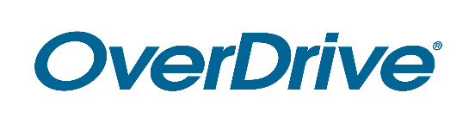

FOR IMMEDIATE RELEASE

Enjoy Streaming Video for Free from Library Name
A variety of video titles now available on the library’s OverDrive app

CITY, STATE – Month Day, Year – City/County residents have access to a wide selection of popular digital ebooks and audiobooks free from Library name. The latest addition to the catalog is streaming videos, including titles like insert 2-3 popular titles here. With a library card, members of the community can borrow from the digital collection by visiting OverDrive library website URL and the OverDrive app.

[Add specific information about the videos and genres offered in collection ie. Spanish-language, instructional, etc.]

[Quote from Library staff member (excitement about the service, first-hand experience using the service, etc.)]

In addition to the new digital video collection, Library name has a large selection of bestselling ebooks and audiobooks (if applicable: and magazines). Readers may browse the library’s digital collection, instantly borrow titles and start reading or listening for free with a valid library card and the award-winning Libby app. This service is compatible with all major computers and devices, including iPhone®, iPad®, Android™ devices, Windows® tablets, and Kindle® [US libraries]. All titles will automatically expire at the end of the lending period and there are no late fees.

To get started, visit OverDrive library website URL.

About Library name
Add boilerplate description

About OverDrive
OverDrive is the leading digital reading platform for libraries and schools worldwide. The company strives to create “a world enlightened by reading” by delivering the industry’s largest catalog of ebooks, audiobooks, magazines and other digital media to a growing network of 50,000 libraries and schools in 78 countries. OverDrive’s popular reading apps provide best-in-class user experience and tools for staff management: the Libby app for libraries is one of PCMag’s Best Free Software of 2019 and Popular Mechanics’ 20 Best Apps of the 2010s, while the student reading app Sora is one of TIME’s Best Inventions of 2019. Founded in 1986, OverDrive is based in Cleveland, Ohio USA and was named a Certified B Corp in 2017. OverDrive is owned by KKR, a leading global investment firm. www.overdrive.com

Contact:
Library contact name
Library name
Phone number
Email address

###

